18 Friendship-Themed Stories
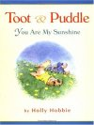Toot and Puddle: You Are my Sunshine by Holly Hobbie. This book is one in a series of books about two adorable pigs, Toot (the adventurer) and Puddle (the homebody), who are best friends. In all Toot and Puddle books, the two friends are affectionate, picking out thoughtful gifts, writing postcards to each other, and looking out for each other. In Toot and Puddle: You are my Sunshine, Puddle goes to great lengths to try to cheer up his friend Toot. Ages 3+
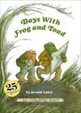Days With Frog and Toad by Arnold Lobel. Days With Frog and Toad includes five short stories — or fables — about two best friends: Frog and Toad. Arnold Lobel is a wonderful storyteller. Lobel’s stories have quirky plots, authentic characters and humor. They are held together by the affection depicted between the two main characters. In Days With Frog and Toad, Frog gently encourages Toad to clean, the two work together to fly a kite, Frog gives Toad a birthday present that does not fit and Toad feels rejected when Frog decides to spend some time alone. Ages 3+
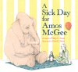A Sick Day for Amos McGee by Philip C. Stead and Erin Stead. A Sick Day for Amos McGee is a very sweet book about a friendship between a zookeeper named Amos and the animals he cares for. When Amos gets sick, his friends elephant, tortoise, penguin, rhinocerous and owl come to his house to comfort and care for him. Ages 3+
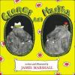George and Martha: The Complete Stories of Two Best Friends by James Marshall. First and foremost, this is a collection of truly entertaining little stories about two best friends, George and Martha. As with real best friends, George and Martha’s interactions are not always perfect (e.g. Martha paints over one of George’s paintings). I like how these stories depict the two friends looking out for each other, learning to balance telling the truth with being considerate of others’ feelings, and arguing and making up. Ages 3+
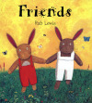Friends by Rob Lewis. Oscar moves to a new town with his mother and tries to make friends. At first, Oscar is critical of each new kid he meets and refuses their invitations to play. Oscar eventually realizes that in order to make friends he will have to be more flexible and try playing new things. Ages 3+
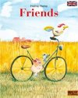Friends by Helme Heine. In Friends, three best friends go on an outing together. They play hide-and-seek, pick cherries, discover an old boat and pretend to be pirates. One line lessons about friendship are interspersed throughout the story. E.g. “Good friends always decide things together.” and “Friends are always fair.” While these lessons would make an older kid cringe, my young kids have all enjoyed this story and not been the least bit deterred by the explicit messages it contains. Ages 3+
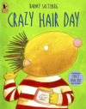Crazy Hair Day by Barney Saltzberg. Readers will feel for the main character in this story, who mistakenly dresses up for crazy hair day when it is picture day, and appreciate his classmates’ super, compassionate response. A wonderful story. Ages 3+
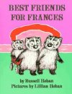Best Friends for Frances by Russell Hoban. Russell Hoban is among my favorite storytellers for children. He does a fantastic job of depicting childhood emotions. In Best Friends for Frances, Frances is left out by her good friend Albert. In retribution, she decides to befriend her sister and go on a no boys outing. In the end, the friends decide that they will not leave each other out in the future. Ages 4+
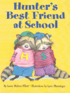Hunter’s Best Friend at School by Laura Elliott. This story describes a scenario commonly encountered by preschoolers and kindergarteners: the best friend getting in trouble at school. In this story, Hunter’s best friend Stripe is acting too silly at school. Hunter follows along, until Hunter’s mom suggests a better solution. Ages 4+

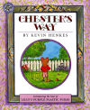Chester’s Way by Kevin Henkes. A super entertaining story, with brilliant illustrations and humorous characters. When Lilly moves into the neighborhood, Chester and Wilson are initially suspicious of Lilly’s eccentric ways. After Chester and Wilson get past their initial distrust, they discover that they have things in common with Lilly, have fun introducing eachother to new things, and ultimately end up being great friends. Ages 4+
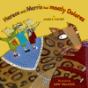Horace and Morris but Mostly Dolores by James Howe. An entertaining story about three spunky mouse friends who mistakenly succumb to the lure of the Mega-Mice (No girls aloud!) clubhouse and The Cheese Puffs (No boys allowed!) clubhouse. In the end, Dolores speaks up and starts an inclusive club devoted to activites that Horace, Morris, and Dolores all enjoy. Ages 4+
Vera’s New School by Vera Rosenberry. Critics of this and other Vera books have noted that Vera Rosenberry’s stories are not particularly reassuring. True. And, I would not recommend this book to a child moving to a new school. I love Vera Rosenberry’s books not because they reassure but because they accurately reflect feelings that many kids face. In this way, Vera Rosenberry’s books remind me of Beverly Cleary’s Ramona books. In Vera’s New School, Vera attends her first day of classes at her new school. While many kids at Vera’s new school miss opportunities to reach out to her, one girl befriends her. This engaging story provides opportunities to discuss what the kids at Vera’s new school could have done to make Vera feel welcome.Ages 4+
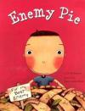Enemy Pie by Derek Munson. A funny story, with instructions for turning a best enemy into a best friend. A very entertaining and satisfying read. Ages 4+
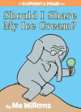Should I Share My Ice Cream? by Mo Willems. Mo Willems series of early readers are not to be missed, whether you are looking for books for emerging readers to read themselves, humorous books to entertain or stories about friendship. Those looking for stories about friendship should check out Should I Share My Ice Cream?, Can I Play Too? and My Friend is Sad. Any messages about friendship flow naturally from the stories Willems tells about best friends Elephant and Piggie. Ages 5+
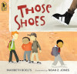Those Shoes by Maribeth Boelts and Noah Z. Jones. InThose Shoes, the main character’s family cannot afford a pair of the shoes — black high tops with two white stripes — that all of his classmates are wearing. Despite feeling left out, the main character is able to reach out to the one other kid in the class whose family can’t afford “the shoes” with a neat act of kindness and generosity. Ages 5+

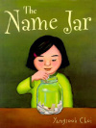The Name Jar by Yangsook Choi. The Name Jar is a story about Korean immigrant Unhei’s first few days at school. Unhei decides to embrace her Korean name, and a boy Joey reaches out to and befriends Unhei. A wonderful story about difference and about reaching out to the new kid at school. Ages 5+

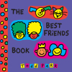The Best Friends Book by Todd Parr. In this upbeat and humorous book, Todd Parr describes best friends as friends who accept you as you are, forgive you, share, visit you when you are sick, make you laugh etc. Ages 3+
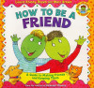How to be a Friend: A Guide to Making Friends and Keeping Them by Laurene Brown. How to be a Friend has explicit instructions about how to be a good friend that would likely sound too preachy to an older kid. However, for the four to seven-year-old kid in the throws of learning how to treat friends, this book has valuable suggestions for joining others who are playing, handling bosses and bullies, and settling arguments.Ages 4+

